**ONLINE SHOPPING MANAGEMENT SYSTEM**

Group Members:

A.Yamini PL0621097

S.Nasrin Banu PL0621103

M.Sivaranjani PL0621104

J.Silvia PL0621108

Chava.Sai Hemantha PL0621123

K.Divya PL0621112

Yegi Varaha Akhil PL0621117

**Table of Contents**

1. INTRODUCTION……………………………………………………………………………….
   1. Existing System
   2. Problem Definition
   3. Why we need a new system
2. SYSTEM REQUIREMENTS………………………………………………………………..
   1. Software Specification
   2. Hardware Specification
3. PROPOSED SYSTEM……………………………………………………………
   1. Advantages of proposed system
4. LIST OF IMPACTED MODULES…………………………………………….

USER:

* 1. Sign-in Page
  2. Login Page
  3. Home Page

4.4 My Cart

4.5 My Orders

4.6 Change Details

* 1. Logout

ADMIN:

* 1. Login
  2. Home Page
  3. Add New Products
  4. Messages Received
  5. Orders Received

5. UML DIAGRAMS…………………………………………………………………………..

5.1Usecase Diagram

6. CONCLUSION…………………………………………………………………………..

**Abstract**

Online shopping sites currently offer online shoppers various combinations of free services such as price comparisons, and/or customer reviews in the search result pages. The utility and market values of shopping comparison sites have attracted internet giants such as eBay, Google, and Yahoo to the extent of developing or acquiring such sites. Scholarly research on comparison-shopping sites has focused on trust in online recommendation agents, and methods used to produce the recommendations. In proposed system, how online shoppers’ attitudes toward comparison shopping sites impact perceived credibility and usefulness of these sites. One interesting finding from our system was that people can need to be strong on product ratings and brand to a wide online shopping in see the videos.

**1. INTRODUCTION**

This project is a web based shopping system for an existing shop. The project objective is to deliver the online shopping application into android platform. Online shopping is the process whereby consumers directly buy goods or services from a seller in real-time, without an intermediary service, over the Internet. It is a form of electronic commerce. This project is an attempt to provide the advantages of online shopping to customers of a real shop. It helps buying the products in the shop anywhere through internet by using an android device. Thus the customer will get the service of online shopping and home delivery from his favourite shop

**1.1** **Existing System**

In existing system Online shopping mall is maintained manually. And online shopping also available but here not provided videos. In manual process, users are move to one place to another place for buying products. This is very difficult so online shopping is best way to buy products. In some cases like searching or identifying products and their quality and quantity may be difficult. To overcome these problems we go for our proposed system.

Advantages in our Proposed System:

* More Convenient
* Better Prices & More Variety
* No Crowds & No Sales Pressure
* Access to used or damaged inventory

**1.2** **Problem Definition**

This system can be implemented to any shop in the locality or to multinational branded shops having retail outlet chains. The system recommends a facility to accept the orders 24*7 and a home delivery system which can make customers happy. If shops are providing an online portal where their customers can enjoy easy shopping from anywhere, the shops won’t be losing any more customers to the trending online shops such as Flipkart or Ebay. Since the application is available in the Smartphone it is easily accessible and always available.

**1.3** **Why we need a new system**

The existing system has the following disadvantages.

* People need to move from one place to another
* More time consuming
* Over crowd
* Sales pressure

To overcome all these limitations we propose a new system of online shopping management system.

**2. SYSTEM REQUIREMENTS**

All computer software needs certain hardware components or other software resources to be present on a computer. These prerequisites are known as system requirements and often used as the guide line as opposed to an absolute rule.

**2.1 Software Specifications**

Operating System: Windows 8+

Frontend: HTML, CSS, Javascript.

Backend: Core Java.

**2.2 Hardware Specifications**  
Processor: i3 Processor  
RAM: 8GB  
ROM: 250GB

**3. PROPOSED SYSTEM**

In proposed system we can buy the products. It will provide types of the clothes with brands of different range of cost with best quality. And we will provide video demo of product quality and their features are visible for in this video compare to others before buy the products. Stress and risk is very less for people and it will take less time for buy.

3.1 **Advantages of the proposed system:**

* Our proposed system has several advantages
* User friendly interface
* Less error
* It will take less time Less risk for people.
* It will provide best quality and features.

**4. LIST OF IMPACTED MODULES**

**4.1. User**

* + Login Page
  + Home Page
  + My Cart
  + My Orders
  + Change Details
  + Logout

**4.2. Admin**

* Login
* Home Page
* Add New Products
* Messages Received
* Orders Received
* Cancel Orders
* Delivered Orders
* Logout

**4.1. USER:**

Sign-in Page:

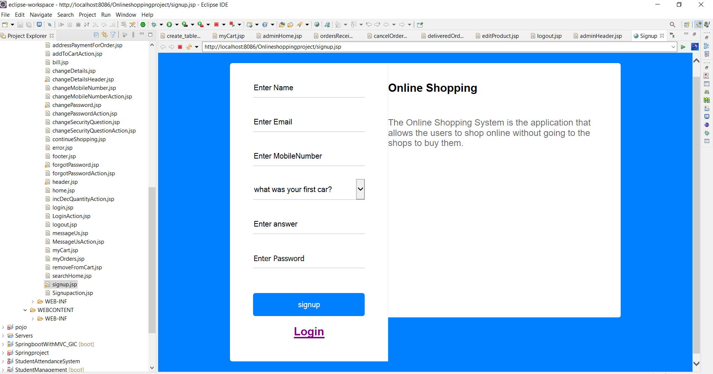

Login Page: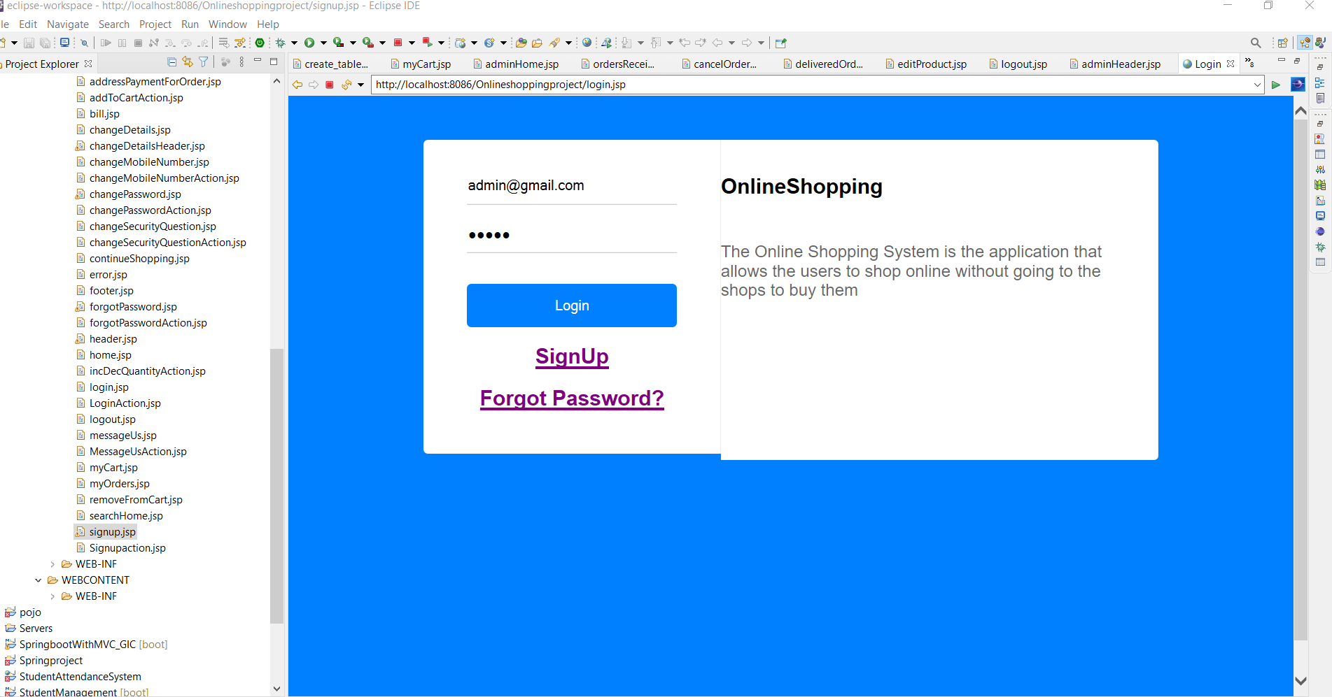

Home Page:

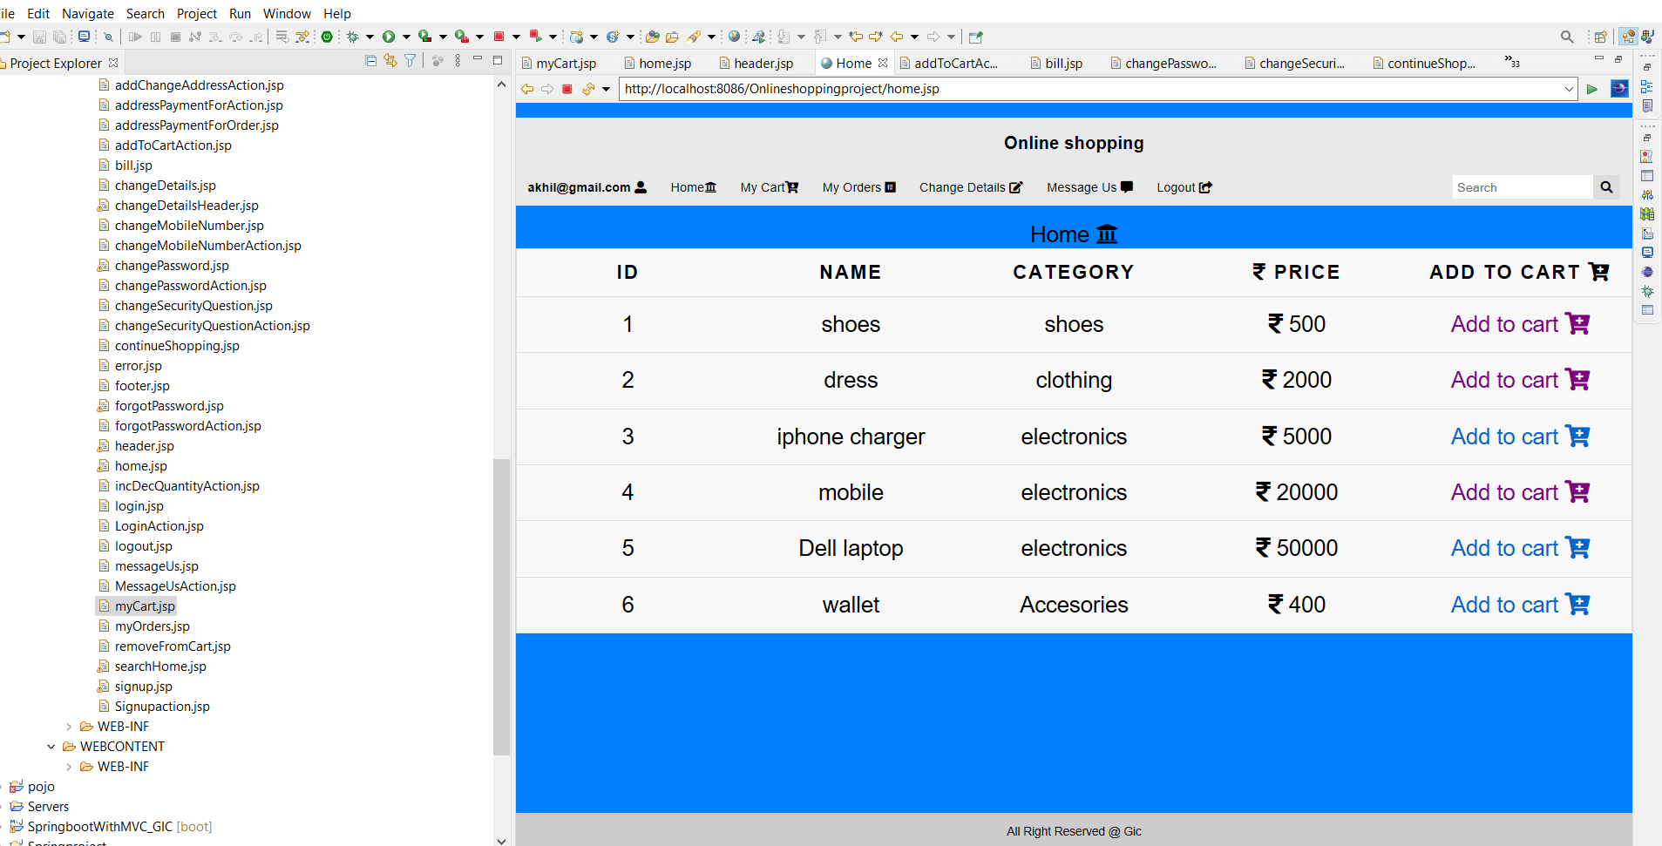

My Cart Page:

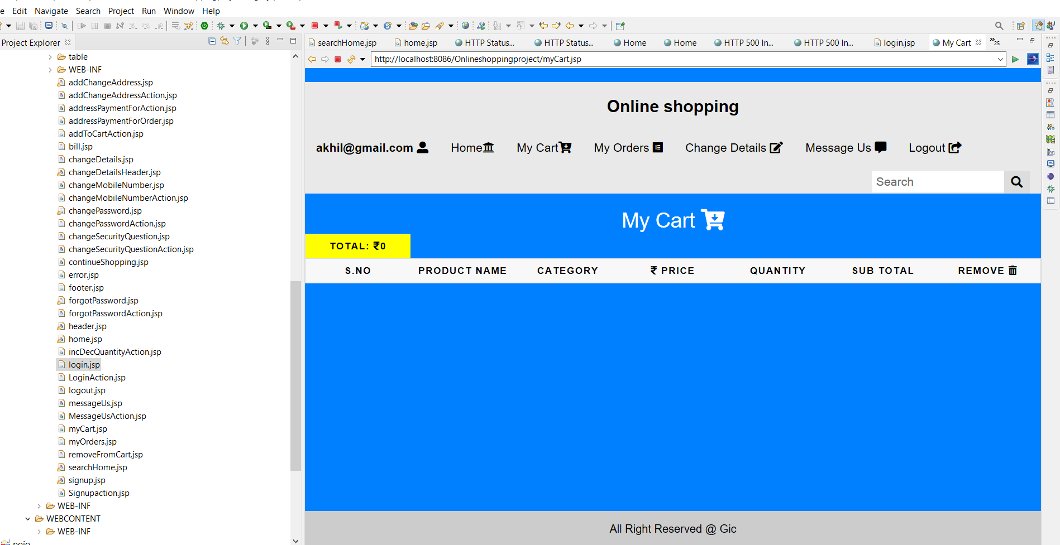

My Order Page:

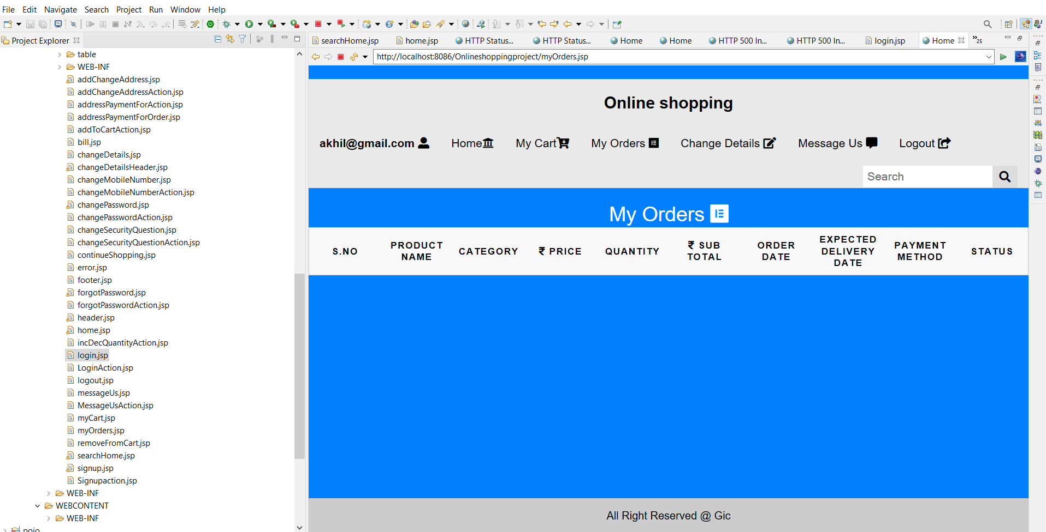

Change Details Page:

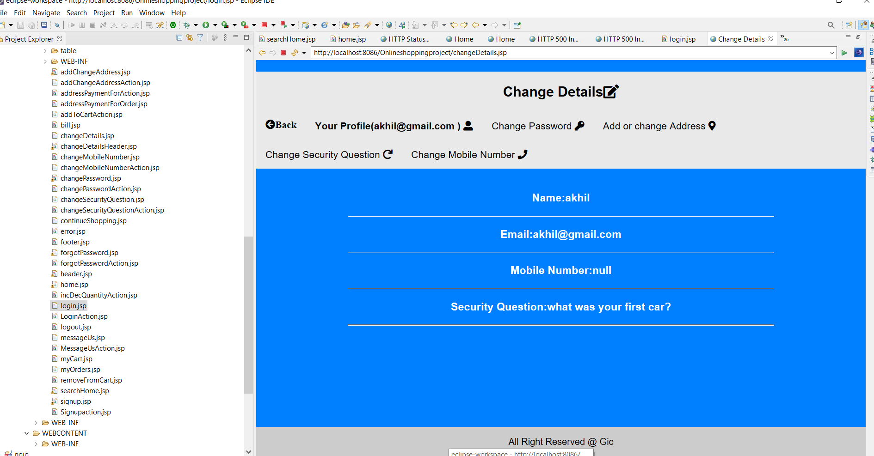

**4.2. ADMIN:**

Login Page:



Home Page:

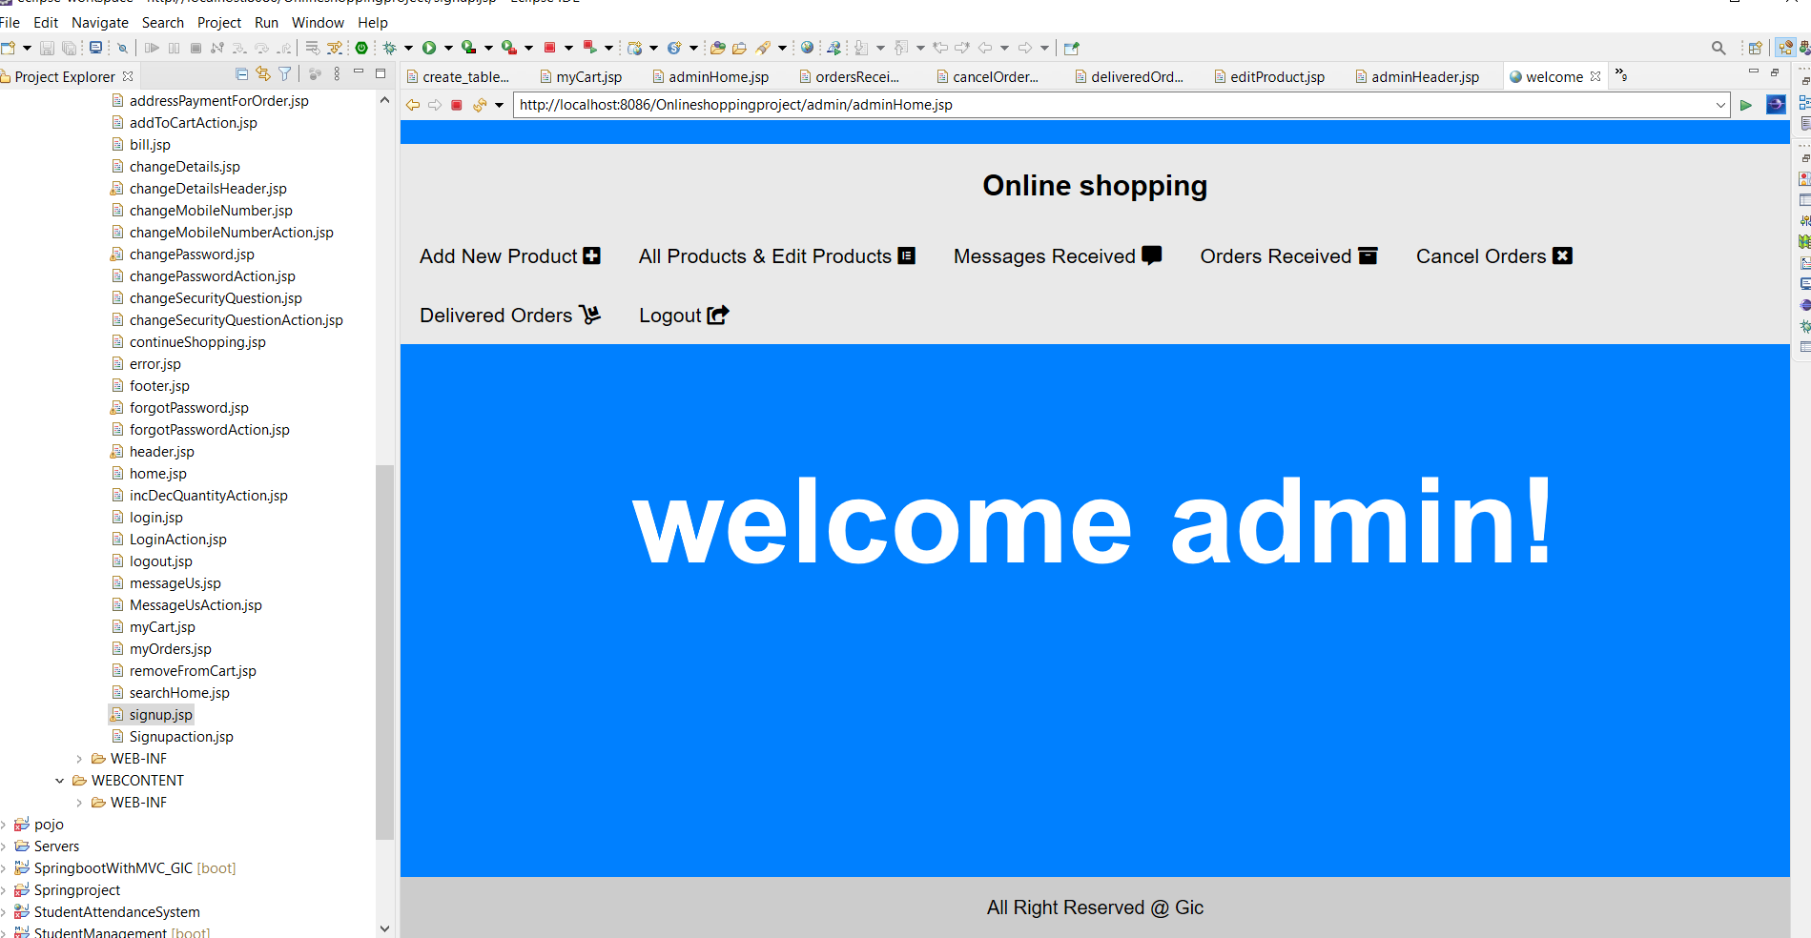

Add New Product Page:

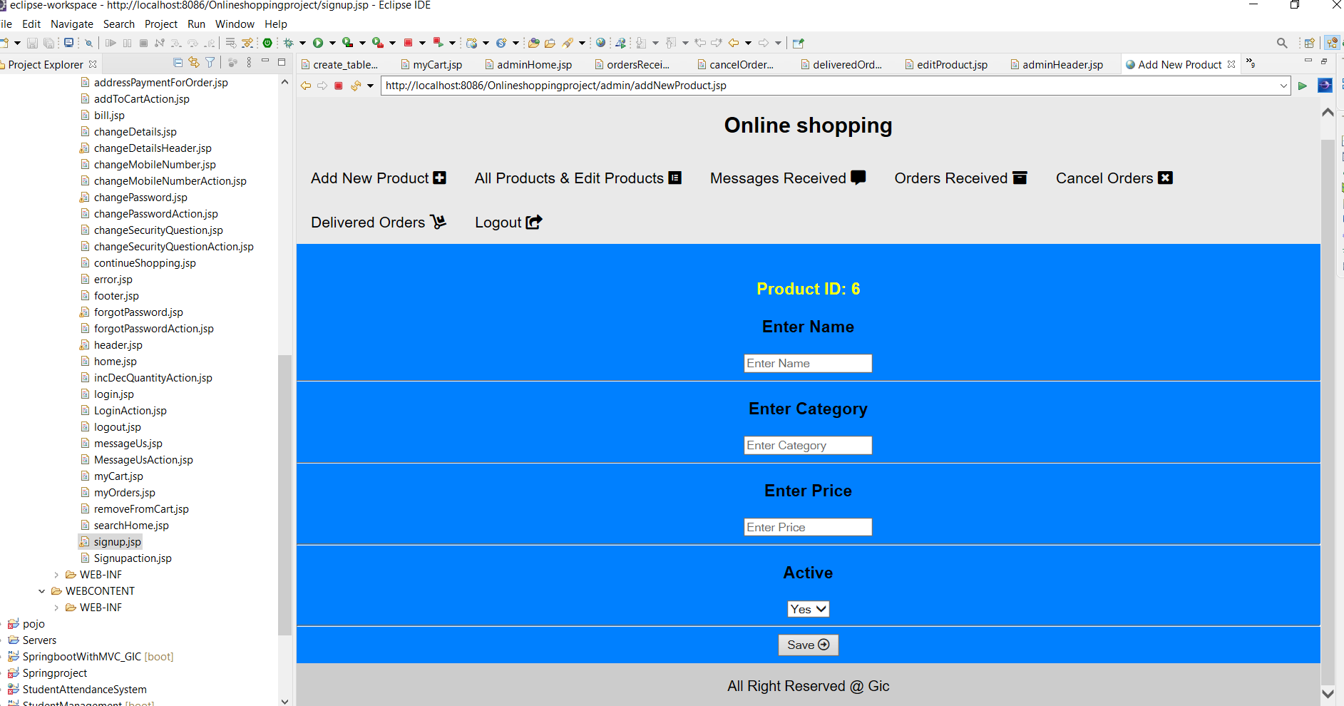

Messages Us Page:

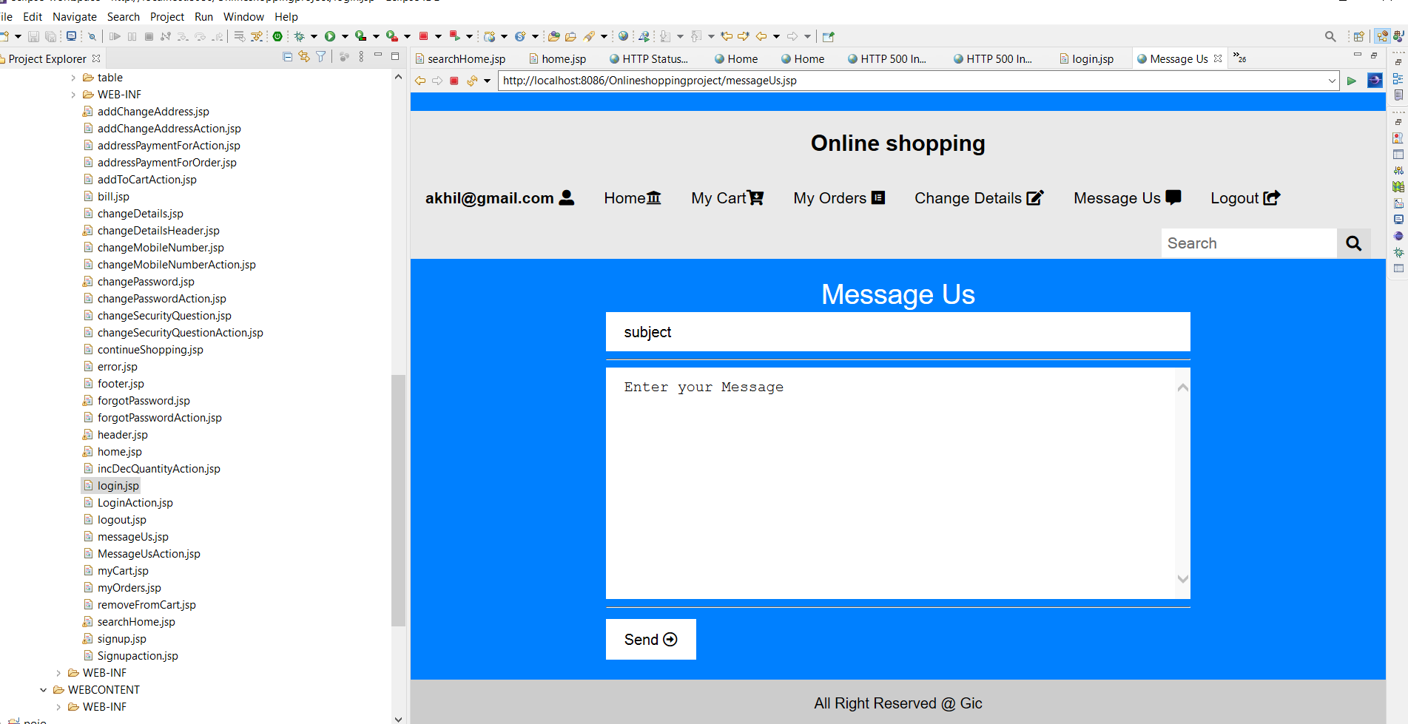

Messages Received Page:

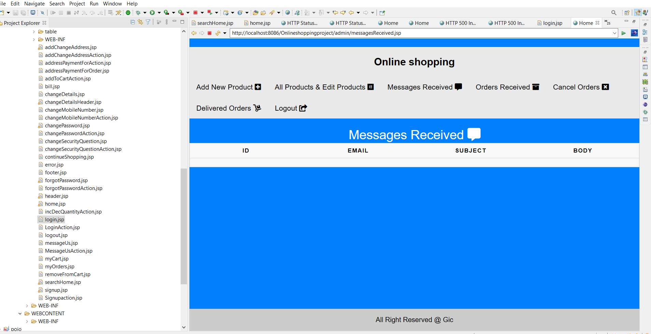

Orders Received Page:

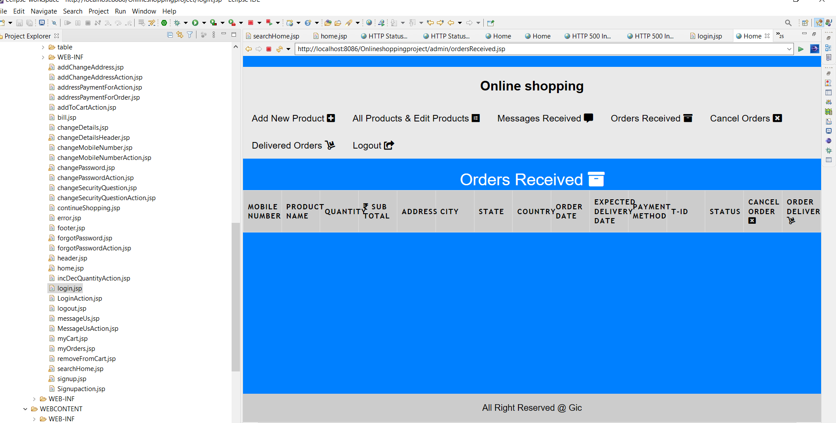

Cancel Orders Page:

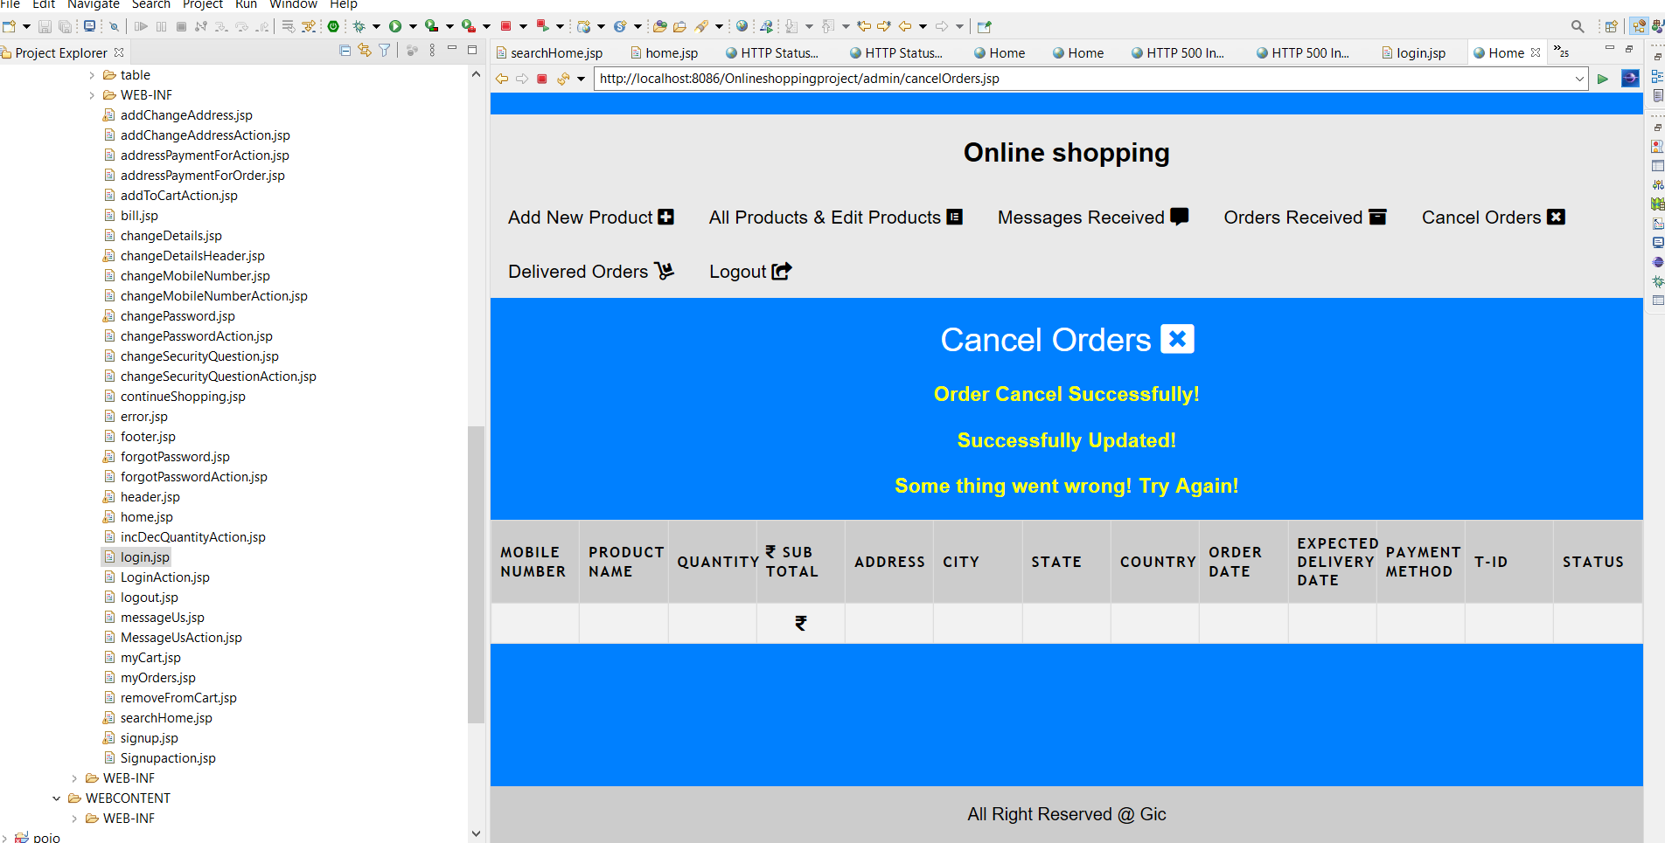

Delivered Orders Page:

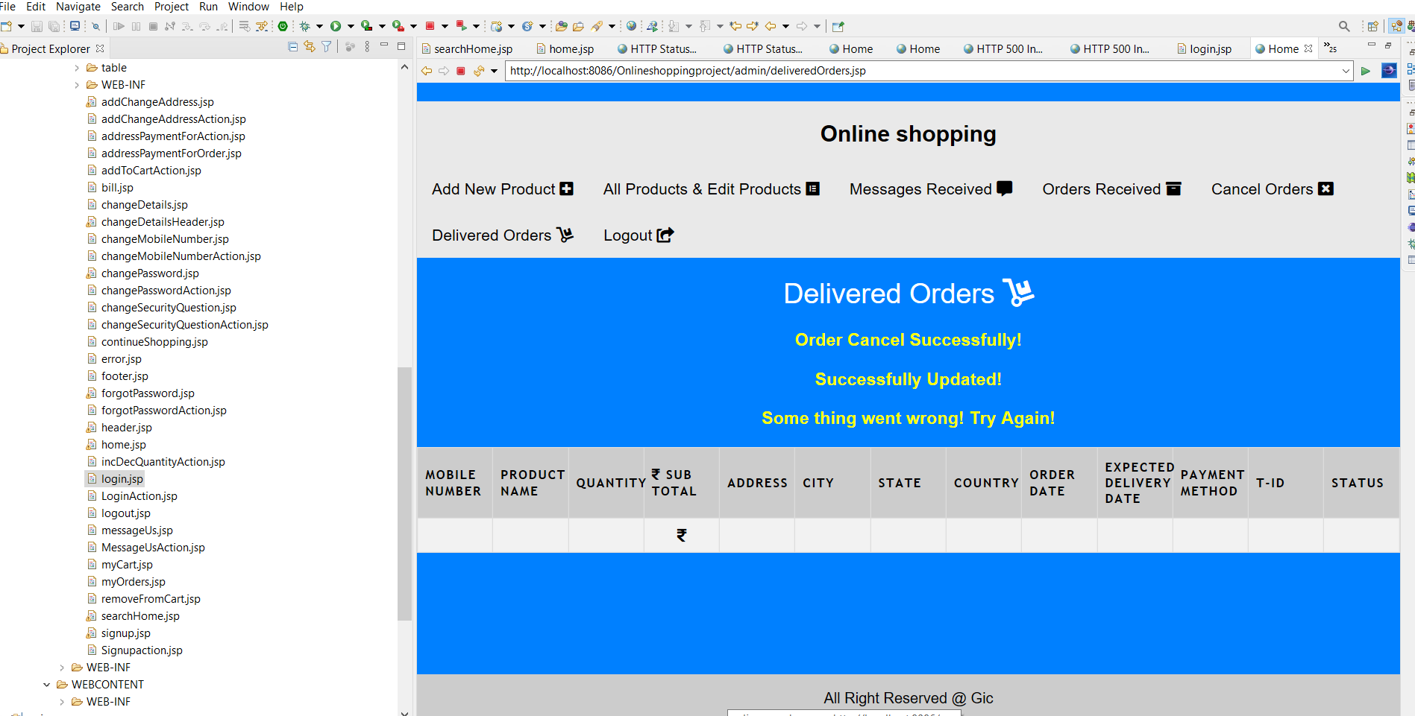

**5. UML DIAGRAMS**

**5.1 Use case Diagram**

**ADMIN**

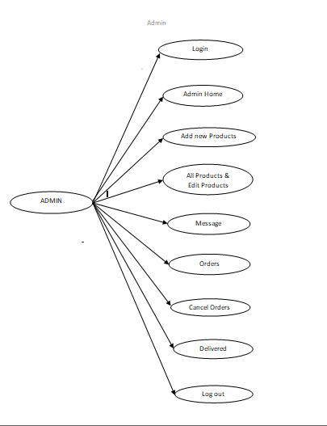

**USERS**

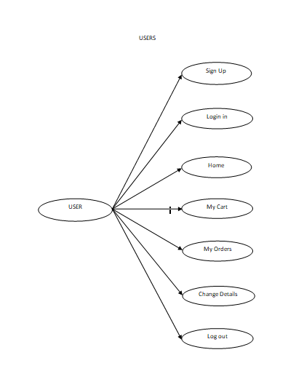

**6**. **CONCLUSION**

The system has been developed with much care and free of errors and at the same time it is efficient and less time consuming. The purpose of this project was to develop a web application and an android application for purchasing items from a shop. This project helped us in gaining valuable information and practical knowledge on several topics like designing web pages using HTML & CSS, usage of responsive templates, designing of android applications, and management of database using MySQL. The entire system is secured. Also the project helped us understanding about the development phases of a project and software development life cycle. We learned how to test different features of a project. This project has given us great satisfaction in having designed an application which can be implemented to any nearby shops or branded shops selling various kinds of products by simple modifications. There is a scope for further development in our project to a great extend. Another feature we wished to implement was providing classes for customers so that different offers can be given to each class. System may keep track of history of purchases of each customer and provide suggestions based on their history. These features could have implemented unless the time did not limited us.